

**MEDI-CAPS UNIVERSITY**

**2019-23**

**SOFTWARE ENGINEERING -PRACTICAL FILE**

**CS3CO26**

CS-A

**Car Pooling Application System**

**Submitted by:**  **Submitted to:**

**EN19CS301050 Ananya Gupta Mrs. Hemlata Patel**

**EN19CS301042 Amit Pandharikar**

**System of Relevance: Car Pooling Application System**

**PRACTICAL - 01**

**Objective:**

To identify the problem and solution statement for a suggested system of relevance.

# Problem Statement:

Transportation is one of major issue which is affecting day to day life of people. Roadway’s traffic is one of the most commonly used networks for moving from one place to another place. In road traffic the majority of road transport consists of the single passenger car. These private cars are mostly used with only a single ride for single person. High traffic congestion is one of the issues which is faced by people in their day-to-day life. Since increased traffic causes pollution, traffic jam, time wastage, more parking space is needed and many more other issues. There is acute problem of traffic on roads these days and the increasing fuel prices add to the misery of daily users of personal vehicles. Also use of vehicles causes pollution which has its adverse effects. Because of increased level in pollution, traffic problems, less space for parking, time wastage and many other issues. In present day world there are no of sources which are used by people but they have certain restrictions i.e., they are limited to certain area. Car sharing is a solution but issues like security and trust come into picture. We have to deal with these issues with the advancement in security features. We have to develop a system that is helpful when either the driver or passenger is in trouble. We have to build such system which is easily accessible to common people. In modern day world everyone has smartphones and access to fast internet is mostly available to each person in our country. Can this problem be solved? Solution to this problem is **Mobile based Carpool system.**

**Existing System:**

All the present available systems have a very attractive and innovative interface which helps the user to understand the system in a easy way. These systems work efficiently and engineered very well by the different sources available. But the problem with available systems is that they do not provide component that builds up trust among the fellow passengers. The reason is all the available sources only concentrate on physical structures of the system.

Drawbacks of the existing system:

• No interaction component available.

• Don’t know with whom you are travelling with.

• Not helpful for blind people.

• Not Secure.

• Not track the location.

• Not Flexible.

**Solution**

Our project aims to reduce overall traffic congestion by reducing the number of vehicles and increasing the share mode of transport for people. This carpooling system will allow secure and safely ride for a user in a user-friendly online system. This carpooling system will have real time updated information to the user. Our system has both types of users i.e registered or non-registered. Users can search for vehicle in pooling system. If a user wants to book a ride, then he has to register his/her name and other information through a login form then he can avail the services of pooling system. Carpooling system also manage details of its customers, drivers, details of vehicles, payment of rides, bookings etc. The core purpose of this system is to build a system that helps in reducing the manual work for keeping the information about car driver’s customers etc. Our carpooling system aims at enhanced business process automation. Also, automation system helps in saving time by satisfying the user requirement. Automation of such systems reduces the cost of collecting and managing the information. This information can be used for resource utilization in an efficient manner. Our system will be completely a web based carpooling system. Web based system means that the system will be available 24/7 except whenever there is a server related problem.

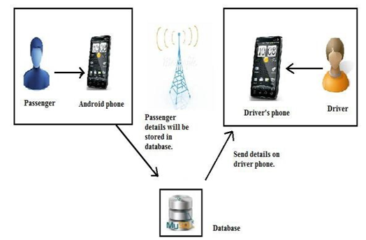

Benefits of carpooling system:

* It has advance facilities to make it more user- friendly.
* It provides details of the owner and his/her car to maintain transparency between users of the system.
* Easy to use, time and money saver system.
* It is available on Smartphone’s so it is more flexible & dynamic to use.
* Provides pool details to the user.
* Can create his/her own pool.